**NUECES COUNTY HISTORICAL SOCIETY**

**PRESENTS**

**Harriet Tillman**

**“Reflections of Corpus Christi during World War II”**

**Tuesday, October 1, 2024, 7:00 p.m.**

**First Presbyterian Church, 430 S. Carancahua Street, Corpus Christi**

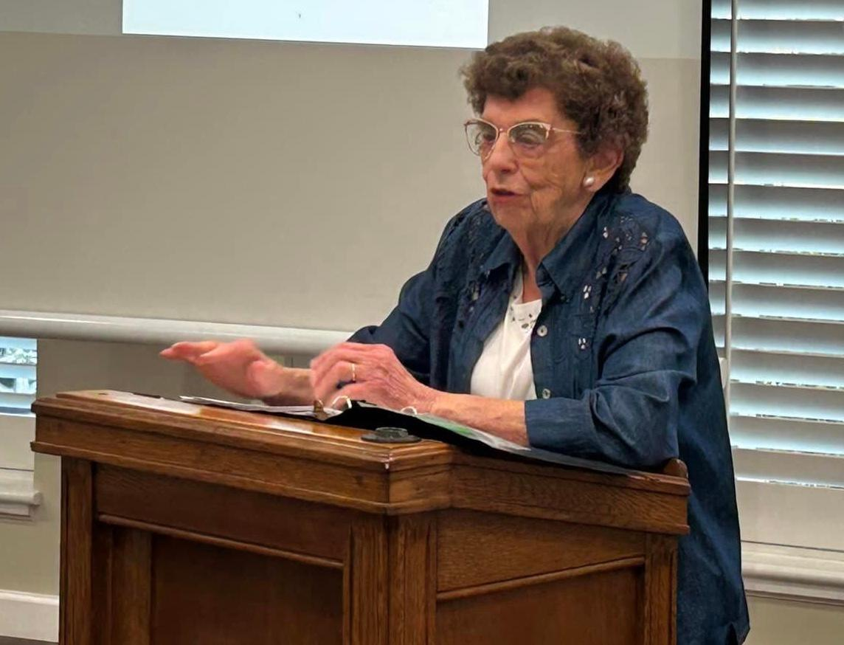

**Harriet Tillman is a retired educator and a long time supporter of all things history! She will share thoughts about WWII in Corpus Christi.**

**\*\* We will also recognize and honor a long time member and local historian, Mary Jo O’Rear, as she moves out of state! \*\***

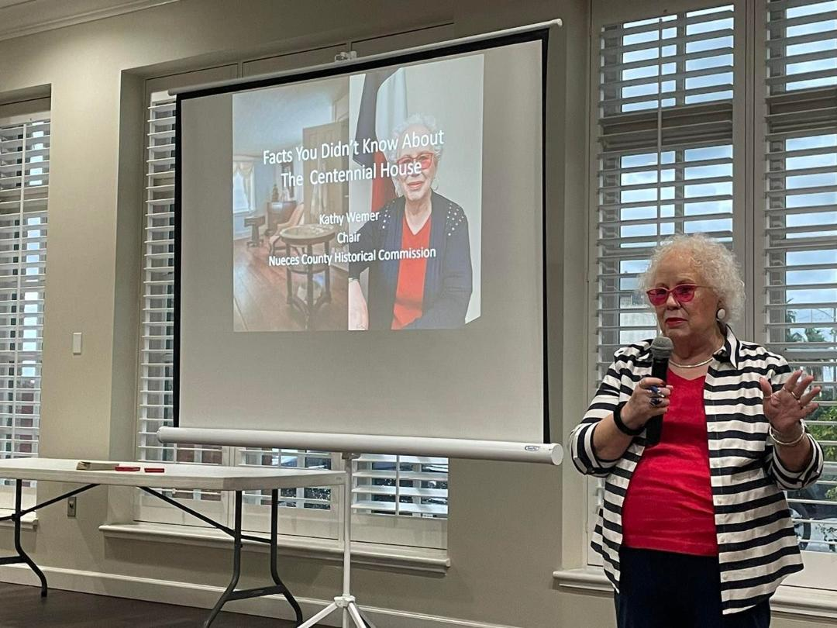

**Kathy Wemer was the speaker at the September meeting. She spoke about the oldest house still in its original location in Corpus Christi.**

**NCHS Mission Statement-The Nueces County Historical Society is a 501©3 multi-cultural organization which encourages a deeper understanding and appreciation for the rich history of Nueces County, the Coastal Bend of Texas, and the United States of America, by members and guests of all ages. It accomplishes this through hosting regularly scheduled presentations with interesting speakers, sponsoring special events, and leading preservation efforts for the area sites of historical significance.**

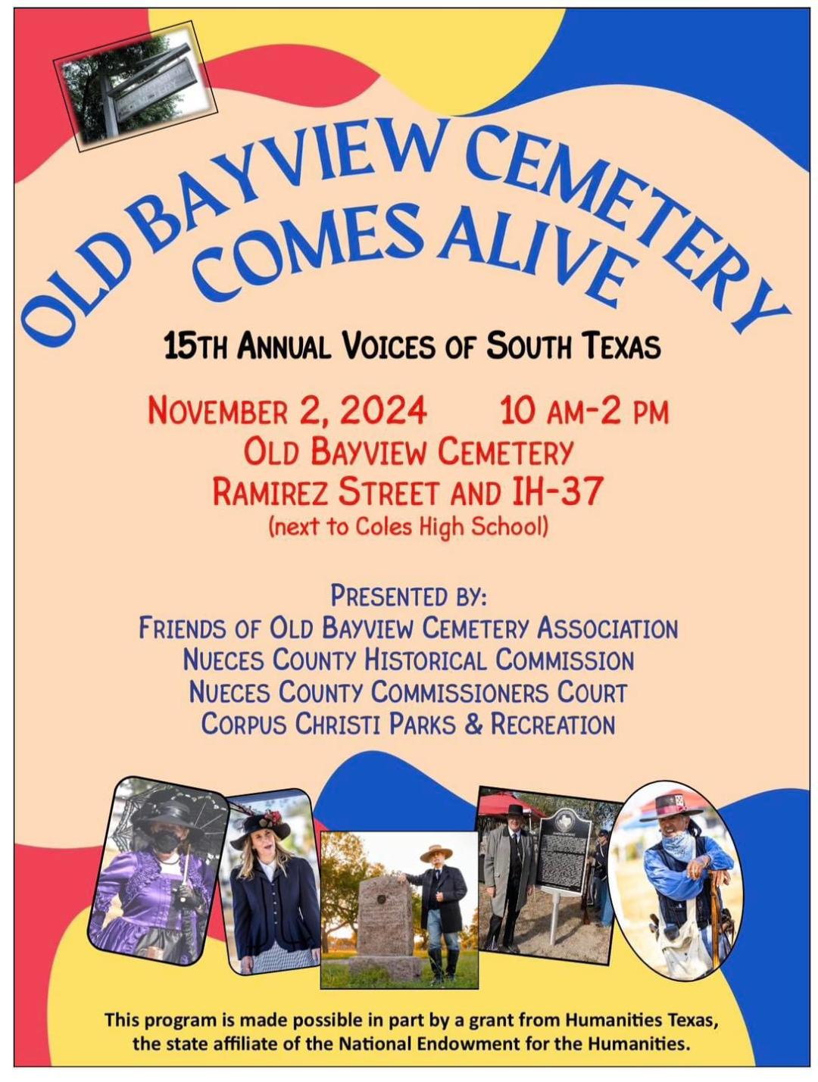

**UPCOMING EVENTS:**

**October 1–NCHS Meeting, 7:00 p.m.**

**October 15-Texas Tropical Trail Monthly Event in Portland\*\*\***

**November 2-“Voices of South Texas” at Old Bayview Cemetery,**

**10 a.m.-2 p.m.**

**November 5-Election Day**

**November 5-NCHS Meeting, 7:00 p.m. The speaker will be Glenn Duhon and the topic will be “1919 Lost Souls.”**

**November 7th-30th-4th Annual Coastal Bend Field of Honor at Borchard Fairgrounds Robstown/Ceremony at 4 p.m. on November 7**

**November 11-Veterans Day Ceremony at Sherrill Park at 10 a.m.**

**December 3-NCHS Meeting, 7:00 p.m., Jim Moloney will be the speaker.**

**December 7-Pearl Harbor Day**

**December 14-Wreaths across America**

**\*\* Contact Sandy Jumper Executive Director, for more info or to get on the mailing list, at** [**info@texastropicaltrail.com**](mailto:info@texastropicaltrail.com)**.**

**The Nueces County Historical Society meets the first Tuesday of the months of September-April. An annual Local History Awards Banquet is held on the first Tuesday in May. Our annual banquet will be held May 6 at Holiday Inn-Airport.**

**Find us on Facebook or on the web at** [**www.nuecescountyhistoricalsociety.org**](http://www.nuecescountyhistoricalsociety.org)**.**

**2024-2026 Officers and Board of Trustees:**

**President: Mary Helen Dunnam**

**Vice President: Kathy Wemer**

**Secretary: Amanda Kowalski**

**Treasurer: Sue Ryland**

**Membership: Michelle Balis**

**Publications/Newsletter Chair: Penny Pillack**

**Publications/Newsletter Administrator: Dylan Bailey**

**Social Media/Webmaster: Mike Carlisle**

**Hospitality: Karen Howden**

**Trustees: Dottie Ewing, RudyTejano Pena, Rene Trevino, Francis Westergren**

**DID YOU KNOW? We all know about the Texas state symbols….the bluebonnet, mockingbird, tree, but do you know these?**

**Sport: Rodeo, adopted in 1997**

**Dish: Chili, adopted in 1977**

**Gem: Topaz (Lone Star Cut), adopted in 1969**

**Grass: Sideoats grama, adopted in 1971**

**Fish: Guadalupe bass, adopted in 1989**

**Plant: Prickly pear cactus, adopted in 1995**

**Shrub: Crape myrtle, adopted in 1997**

**Cobbler: Peach, adopted in 2013**

**Native shrub: Texas sage, adopted in 2005**

**Dog: Blue Lacy, adopted in 2005**

**State vehicle: Chuck wagon, adopted in 2005**

**Footwear: Cowboy book, adopted in 2007**

**Snack: Tortilla Chips and Salsa, adopted in 2003**

**IT IS NOW TIME TO SUBMIT YOUR DUES FOR 2024-2025.**

**The Nueces County Historical Society**

**NCHS Membership Year: September 2024 to August 2025**

**Name__________________________________________________________**

**Address________________________________________________________**

**City____________________________ State_____________ Zip___________**

**Home Phone_________________________ Cell Phone__________________**

**Email__________________________________________________________**

**Please select Membership Category:**

**_____Military Veteran No Charge (Present DD 214 or military ID)**

**_____Individual $15.00**

**_____Family $20.00**

**_____Student $4.00**

**_____Patron $50.00**

**_____Sustaining Patron $100.00**

**_____Supporting Patron $150.00**

**_____Benefactor $250.00**

**_____Corporate $250.00**

**_____Angel $1,000.00**

**Please remit dues check with this membership form to:**

**Nueces County Historical Society**

**P. O. Box 60003**

**Corpus Christi, Texas 78466-0003**

**OR BRING TO THE NEXT MEETING…**